Creating your own cryptocurrency token on the Ethereum blockchain can be done using token creation platforms that provide user-friendly interfaces. One such platform is https://test-mint.trustswap.org/create-coin. Here are the steps to create your token.

1. Create a Metamask account. You can do this by downloading Metamask extension on your chrome browser device by visiting the metamask website.
2. Fund your Metamask account with ETH. You can do this by using test ETH Token from https://sepoliafaucet.com/ and then transferring it to your Metamask account.
3. Go to the Trust Swap website. Once you have funded your Metamask account, you can go to the Trust Swap website and click on the "Start Creating Token”.
4. Enter the details of your token. This includes the token name, symbol, supply, and decimals.

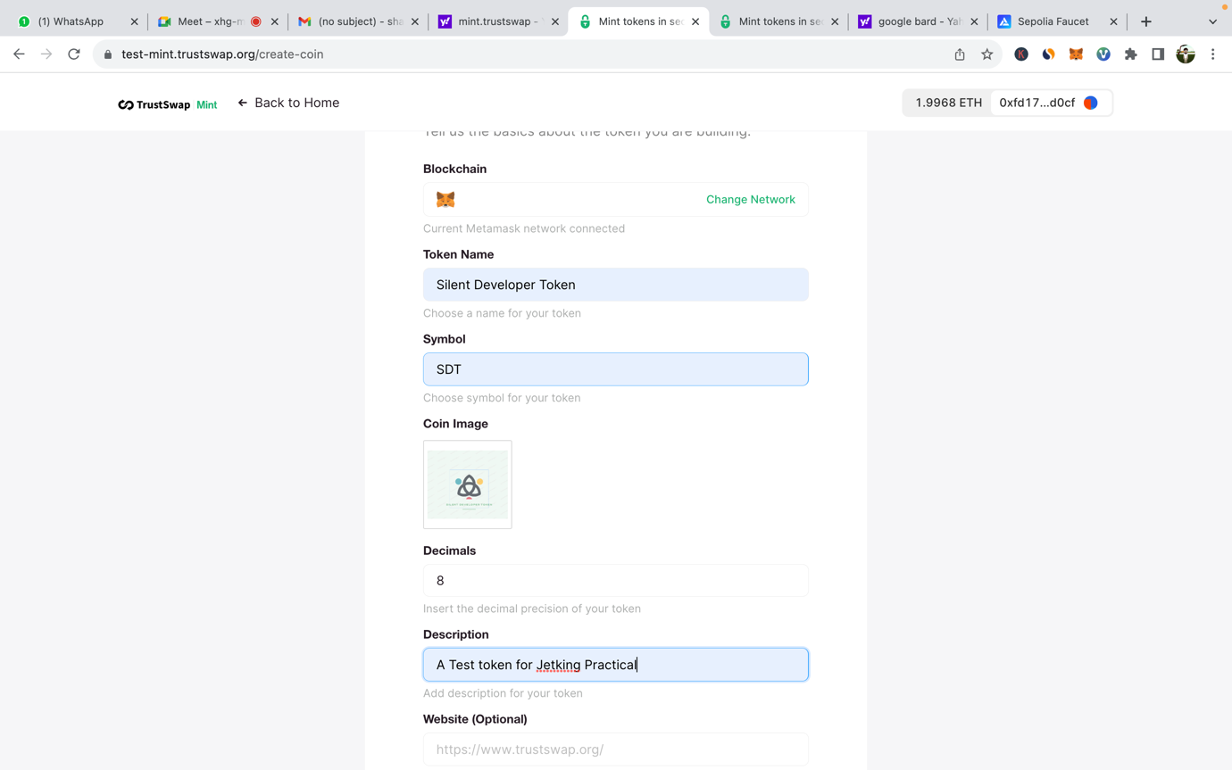

1. Review the details of your token. Once you have entered the details of your token, you will be able to review them before you deploy it.

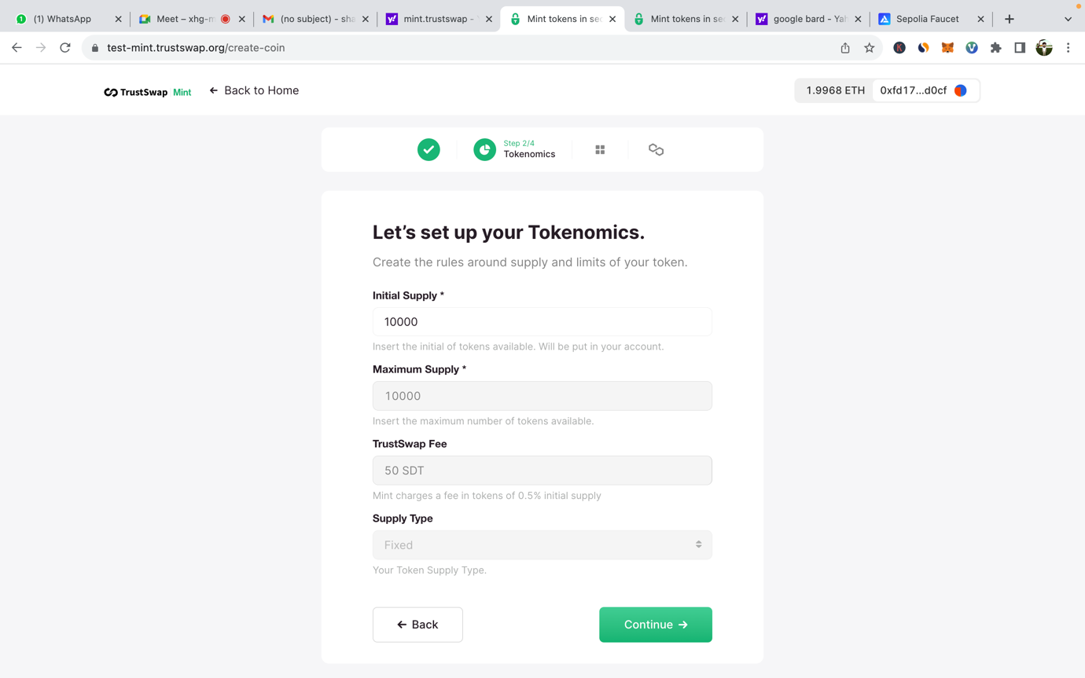

1. Deploy your token. Once you have reviewed the details of your token, you can click on the "Deploy" button to deploy it.

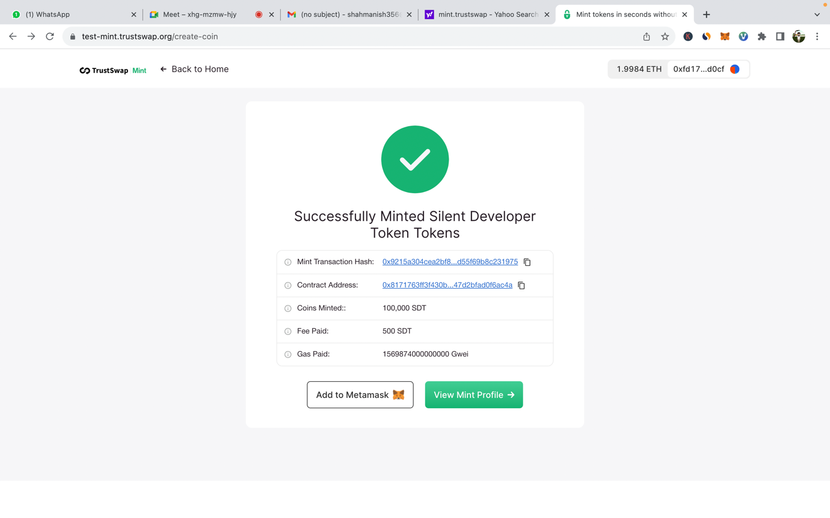

1. Receive your tokens. Once your token has been deployed, you will receive your tokens in your Metamask Wallet.

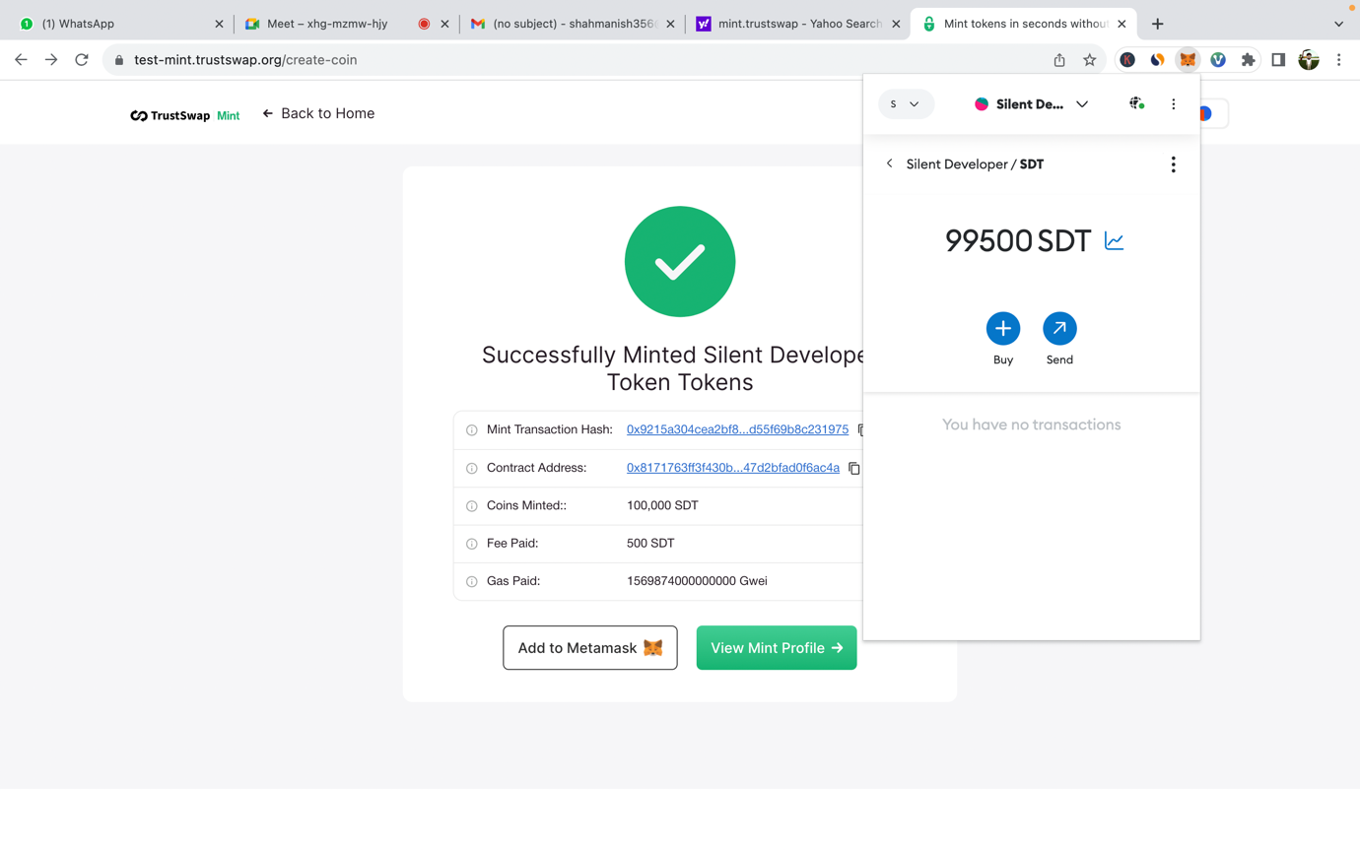

Contract Address: 0x8171763ff3f430bbe73311b5447d2bfad0f6ac4a

Mint Transaction Hash: 0x9215a304cea2bf8af0843307858a93c67722c9d759932d0cfd55f69b8c231975